Directed Independent Study Fall 2019

Leadership Hours Tracking

Shyam Rajendren

DATABASE DESIGN/SCHEMA

This database diagram has been created in the SQL Server Management Studio (SSMS) and has been given the name “ActivityDB”. It has three tables: Student, ActivityItem and Semester. Student diagram is to contain the student’s N# and related attributes. Semester is a lookup table to capture terms such as Fall 2019, Summer 2019, etc. This table will be preloaded with all terms. The ActivityItem table is to capture data related to each event that the student has participated in. Two one-to-many relationships are created for data item N-Number and Term.

Below is the database diagram from SSMS.



**Figure 1. Entity Relationship Diagram**

The column attributes in each of the table is listed below:

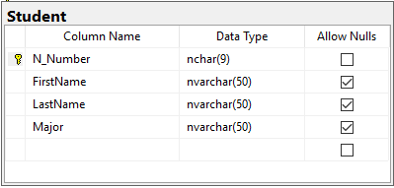

N_Number is the primary key in the “Student” table

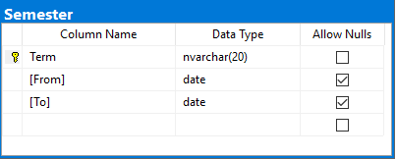

Term is the primary key in the “Semester” table.

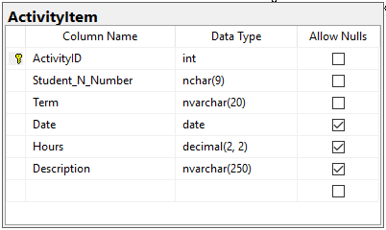

ActivityItem is the key table in which a student’s activities that are to be tracked are stored. It has two one-to-many relationship: 1) Student_N_Number to N-Number in the Student table and 2) Term to Term in the Semester table.

The above database model was imported to Visual Studio as a data item using the

ADO.NET Entity Data Model framework which creates three c# classes representing each table.

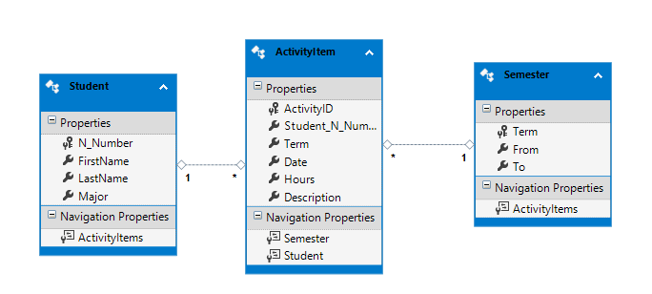

**Figure 2. ER Entity Model**

WIREFRAMES

1. Landing page:  
   Student list is the landing page. This page will contain all the students in the system.

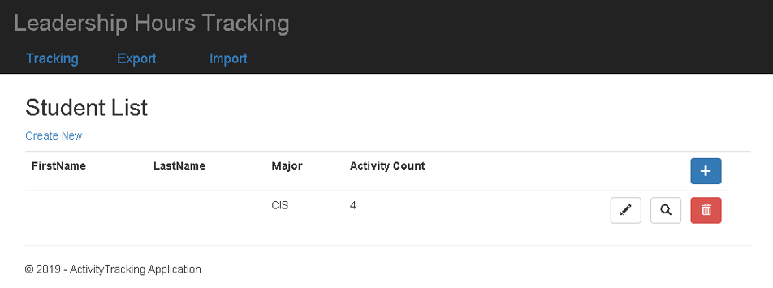

There are three links at the top of the page: 1) Tracking – the landing page 2) Export – export table data into Excel and 3) Import Excel data into tables.

1. “Create New” on the landing page brings up the “Student Edit” page and allows a new student to be added to the system. The + icon can also be used to add a new student.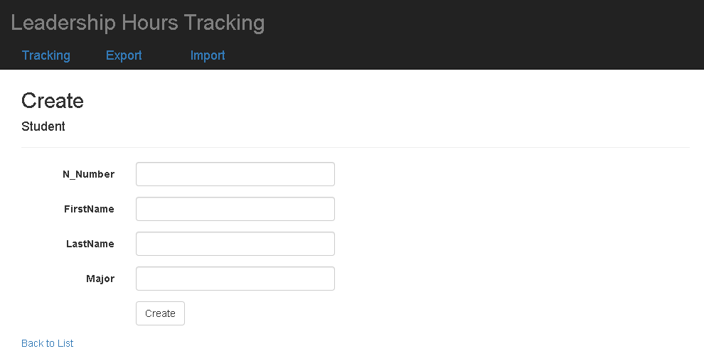  
   Clicking the “Create” action brings up the landing page with “Student List”.
2. From the “Student List”, when “Delete” (Recycle bin icon) is clicked, it brings up the student “Delete” page. Upon clicking the “Delete” button, student row and all the associated activities will be deleted.

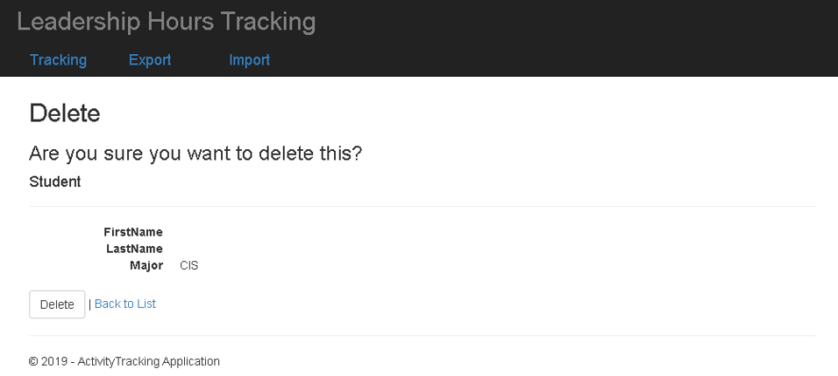

1. From the “Student List”, when “Edit” (pencil icon) is clicked, the student detail page along with “Activity List” is brought up.

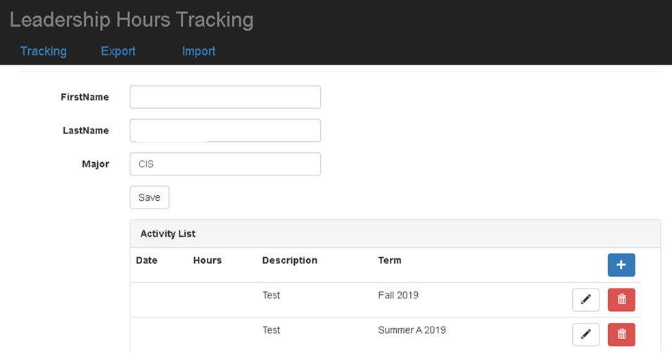

1. From the “Activity List”, when the “+” icon is clicked, it brings up the Activity “add” page.

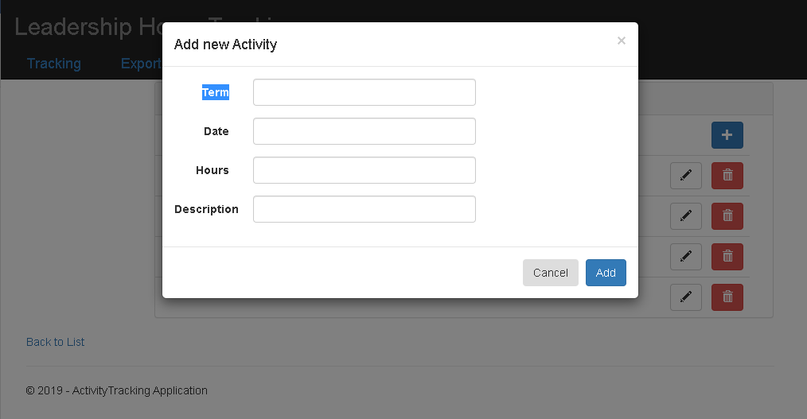

“Add” will add the activity.

1. From the “Activity List”, when the pencil icon is clicked, the activity “Edit” page is brought up.

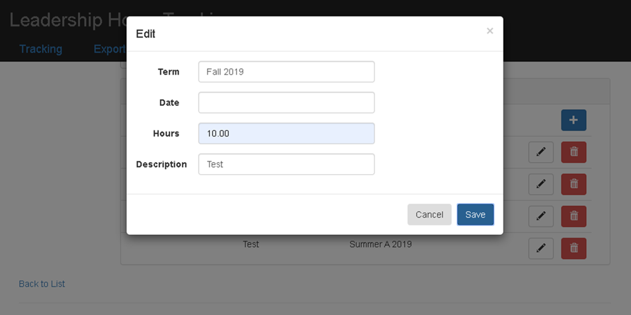

“Save” will save the changes to the activity table.

1. From the “Activity List”, when “delete” (recycle bin icon) is clicked, the activity “Edit” page is brought up.

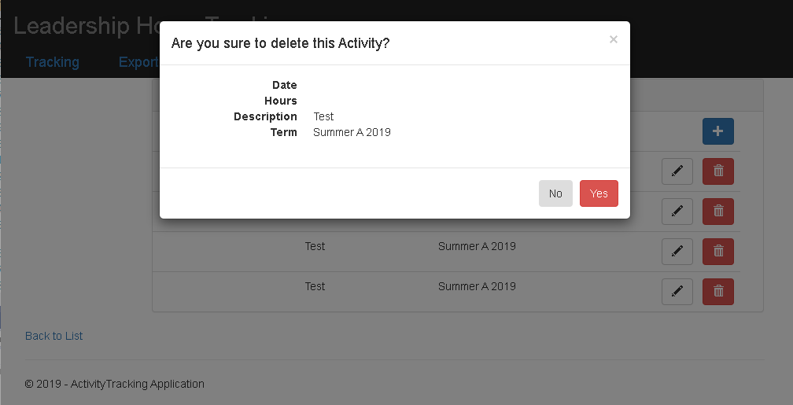

Upon confirmation by clicking “Yes”, the activity will be deleted from the ActivityItem table and thereby be removed from the Activity List page.

1. From the “Activity List”, when Edit (pencil icon) is clicked, it brings up the activity “Detail” page.

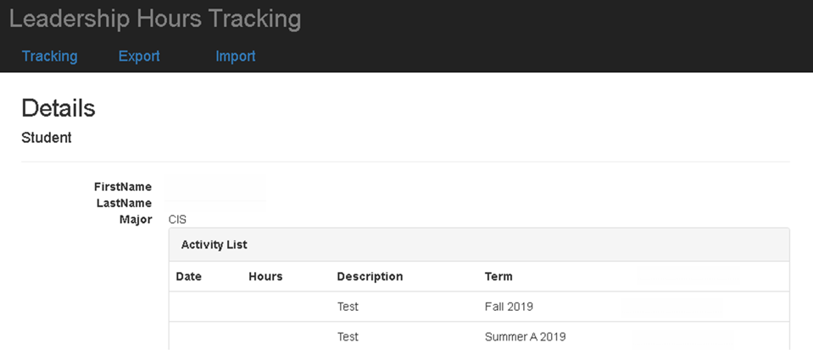

1. Export ActivityDB table data into Excel.

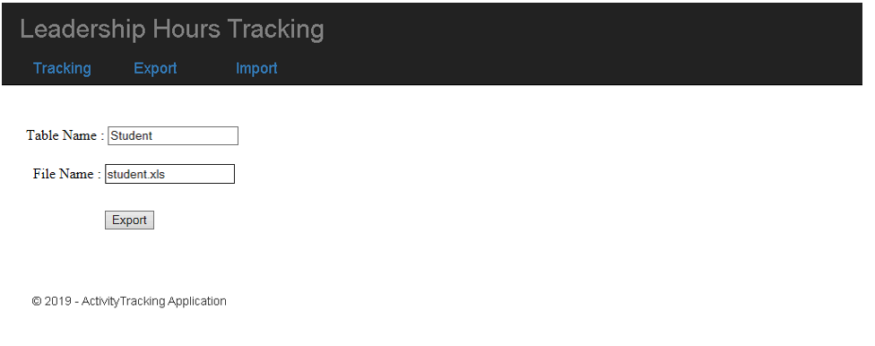

1. Import Excel data into the ActivityDB table

